Arrays
- Variable at any point of time can store only one value but to store multiple values at a time we go for an array.
- As Every variable has a name every array also has a name.
- Whenever we store any values in an array it is always stored in an indexed order

There are two ways to create an array
1. In the first approach of array there are three stages
- Declaration
- Instantiation (Object creation)
- Initialization
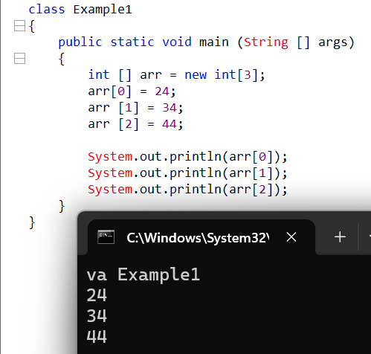
- Arrays by nature are homogenous.
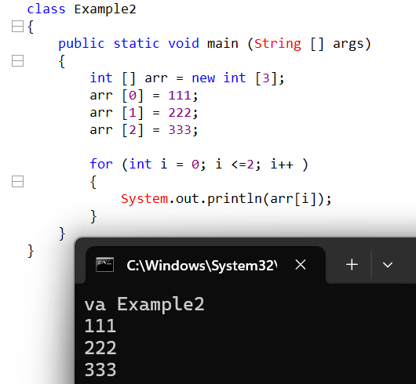
- Depending on size of array creating that many numbers of statements will consume lot of memory hence to avoid that we prefer to go for loops.
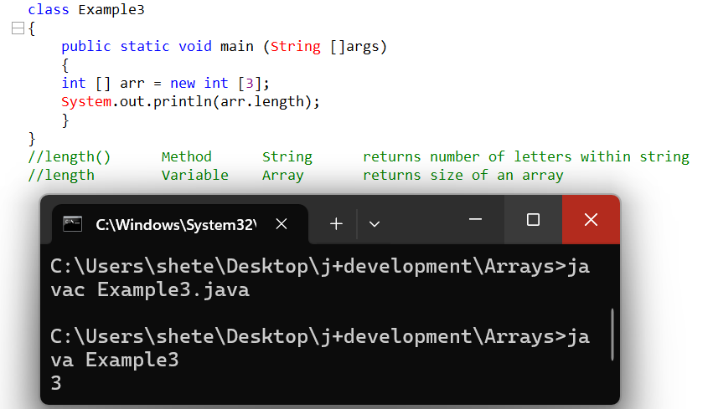
- What is difference between length method and length, length method is used to calculate the length of the string which will return number of letters or numbers or special characters within a string but whereas length is used to calculate the size of an array.

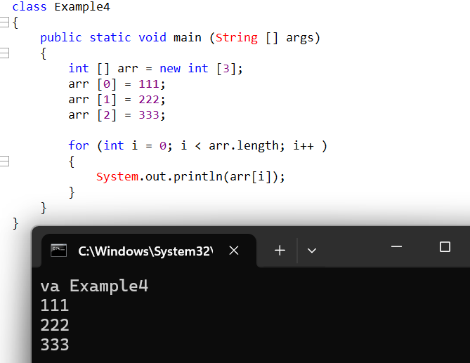
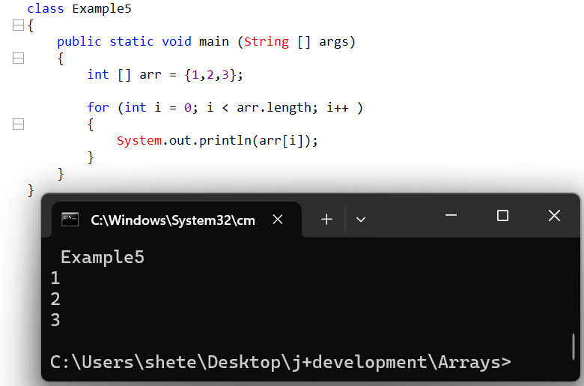

- Arrays are not only meant to store primitive data but they are also meant to store object data.
- Arrays internally are treated as classes (we use new keyword)
- Arrays come under non primitive data types.
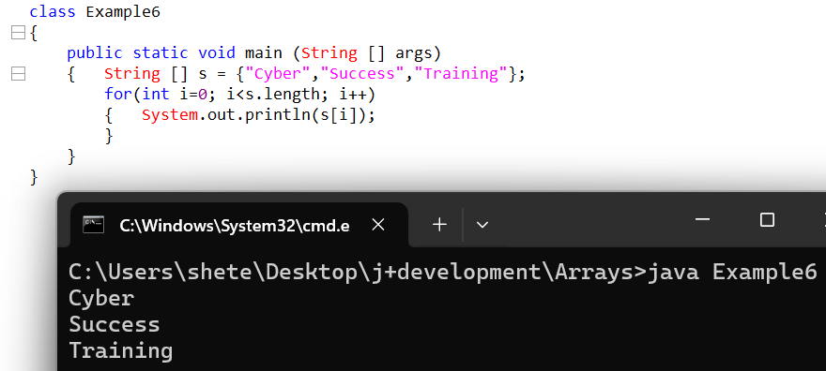

For-Each loop
For(store the data based on the extracted data: from where to extract data/info)
For(int aa: a)
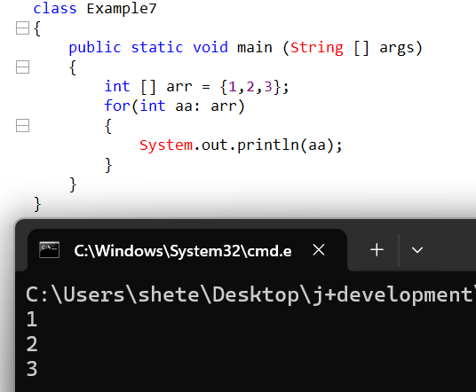
- The way for each loop works is it will by default start from index zero and extract the data and store it.
- While storing the type should be same as extracted data.
- The for each loop will keep on extracting the data till the end of the array by using auto increment feature.
- The for each loop will identify the end of the array without using any condition.

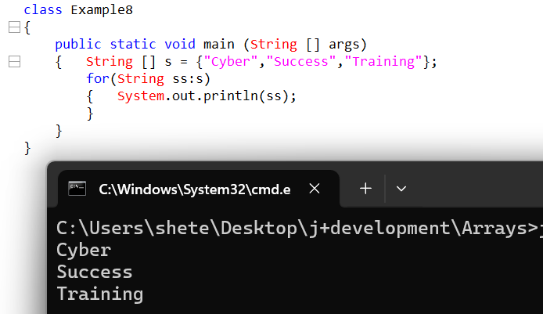
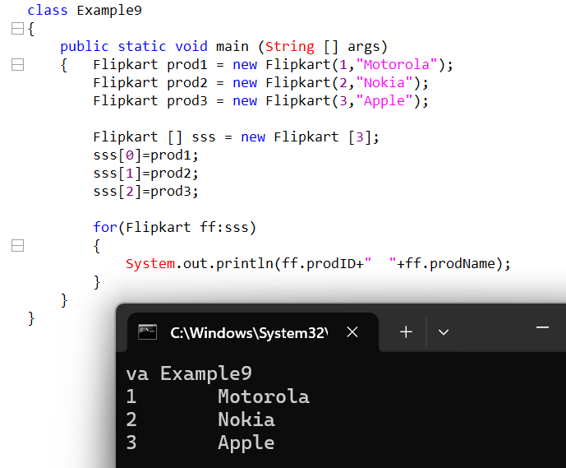

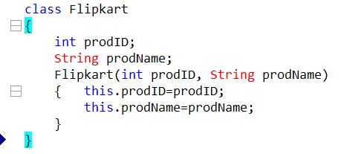

- If we do not initialize the array then java will initialize the array with default values.
- If it is primitive array it will initialize primitive default data.
- If it is an object array it will initialize null values.
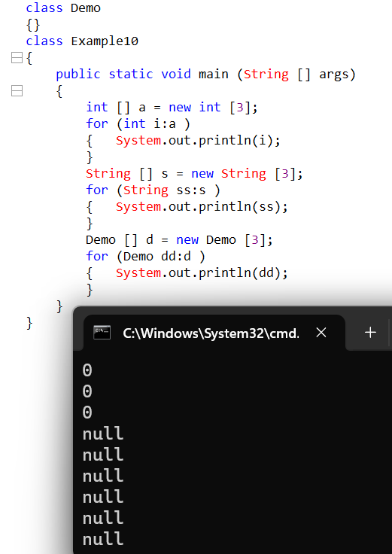

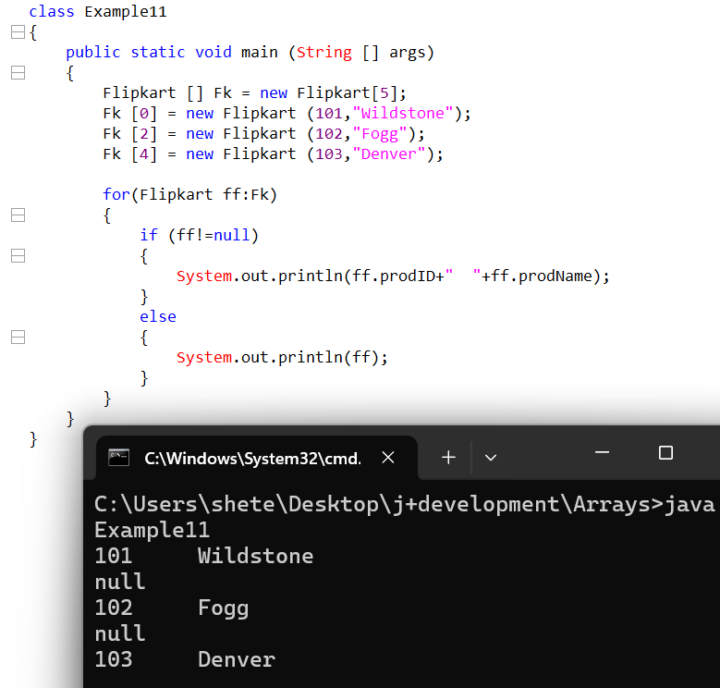

The instance of operator is used to check is a reference belongs to a particular instance or not.
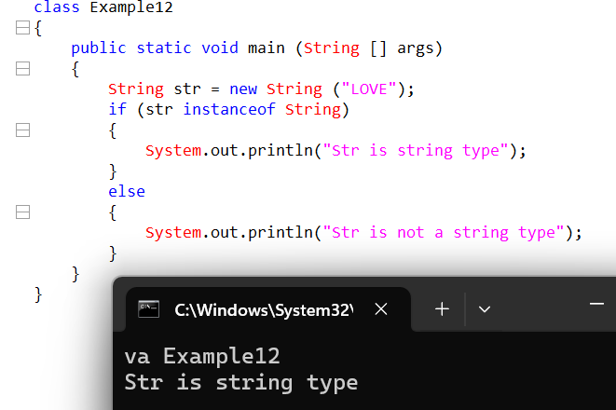
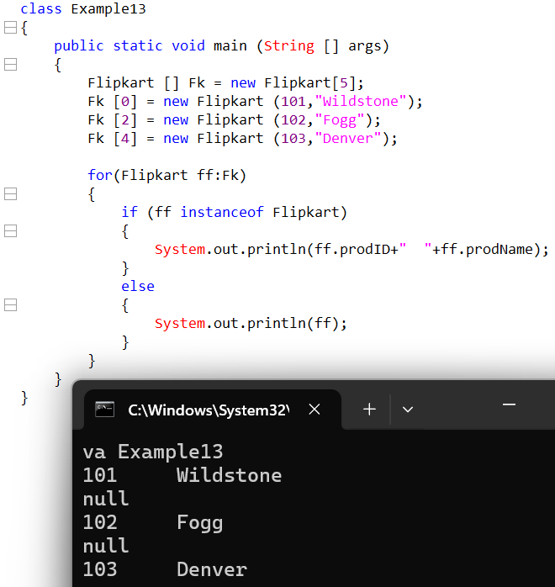
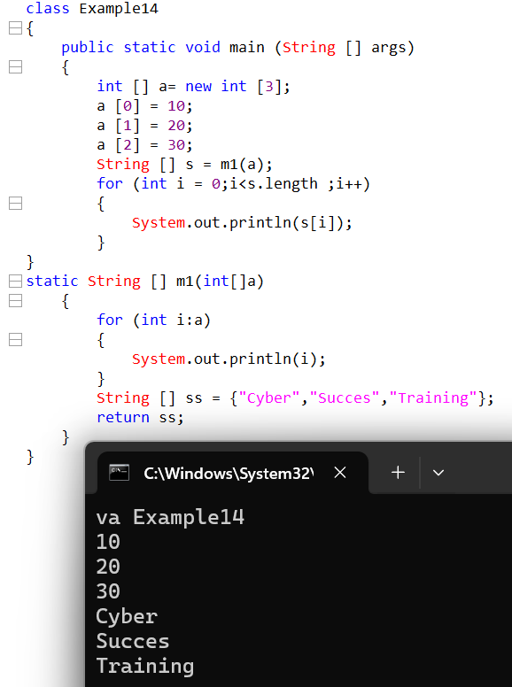

Arrays are mainly categorized into two types
1.Single Dimensional(1D)
2.Multi-Dimensional (2D)
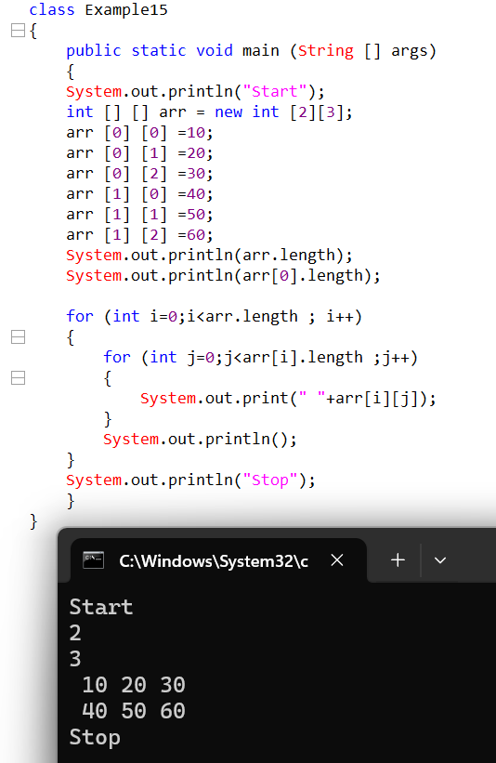
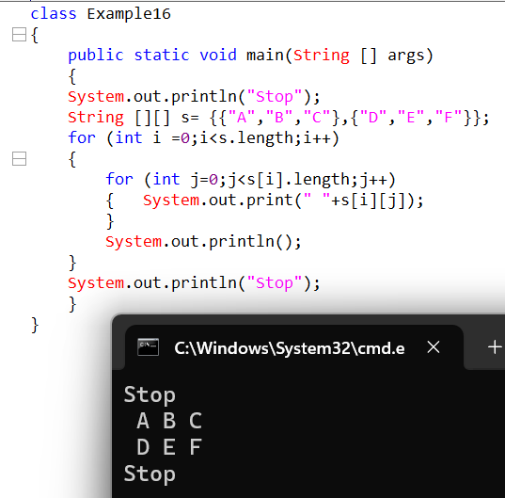
In a single dimensional we have multiple rows and a single column but in a two dimensional or multi-dimensional array we have multiple rows and multiple columns.
Is it possible to create Heterogenous Array
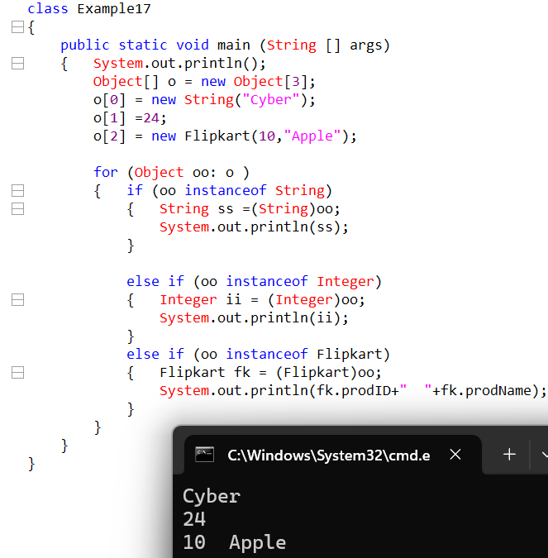

Limitations of Array
- Arrays by nature are fixed in size.
- The size of an array does not change during the runtime.
- Arrays do not support the concept of methods.
Hence to overcome the above limitations we prefer to go for Collections.

Benefits of Collections
- Collections are not limited to particular size.
- Collections can change its size dynamically during the runtime.
- Collections do support the concept of methods hence performing operations becomes much easier.

